DATA STRUCTURES AND ALGORITHMS

EXPIREMENT : 2

NAME: Lakshmi Prabha M M

ROLL NO: 25BAD049

QUESTION 1
AIM:
To write a program using the Two-Pointer technique to square each element of a sorted array and produce the squared values in non-decreasing sorted order with $O(N)$time complexity.
PSEUDO CODE:
START
Read N
Read array arr[N]
Create array result[N]
left ← 0
right ← N - 1
index ← N - 1
WHILE left ≤ right DO
IF abs(arr[left]) > abs(arr[right]) THEN
result[index] ← arr[left] * arr[left]
left ← left + 1
ELSE
result[index] ← arr[right] * arr[right]
right ← right – 1
END IF
index ← index - 1
END WHILE
FOR i ← 0 TO N - 1 DO
Print result[i]
END FOR
STOP
SOURCE CODE:
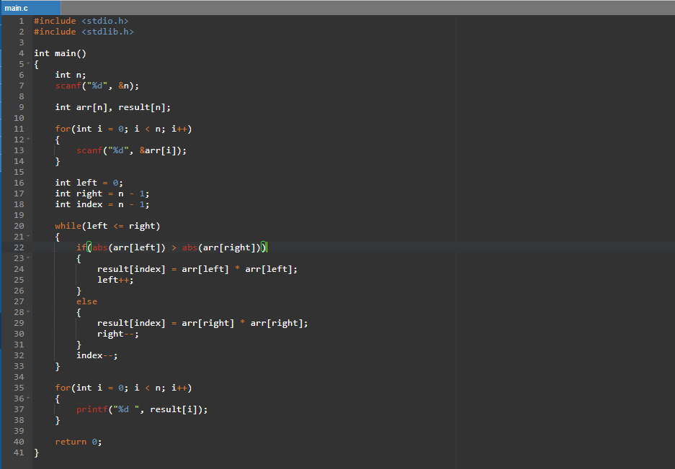
OUTPUT:
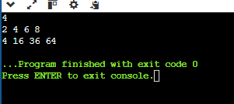

RESULT: https://github.com/prabha4678-git/24CSI024-25BAD049/blob/603b445bffb498311ccab7d2944e4b8a7e3888f2/ex2code1.c

QUESTION 2
AIM:
To write a C program to compute the cumulative (prefix) sum of an array using the Prefix Sum technique.

PSEUDO CODE:
START

Read N

Read array arr[N]

Create array prefix[N]

prefix[0] ← arr[0]

FOR i ← 1 TO N-1 DO
prefix[i] ← prefix[i-1] + arr[i]
END FOR

FOR i ← 0 TO N-1 DO
Print prefix[i]
END FOR

STOP
SOURCE CODE: 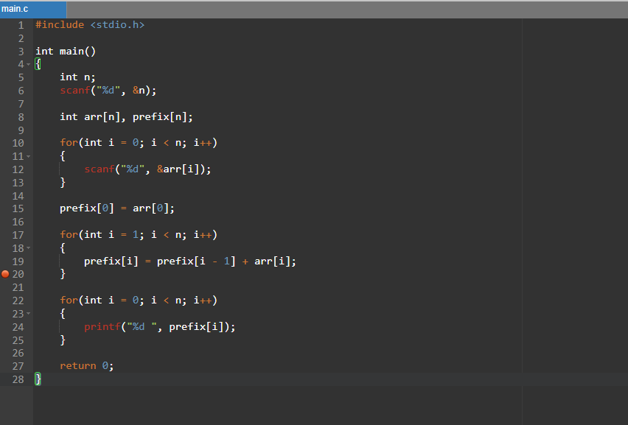

OUTPUT:
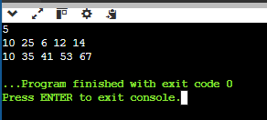

RESULT:https://github.com/prabha4678-git/24CSI024-25BAD049/blob/603b445bffb498311ccab7d2944e4b8a7e3888f2/excode2.c

QUESTION 3
AIM:
To write a C program to find the minimum number of swaps required to group all active sectors (1s) together using the Fixed-Size Sliding Window technique.
PSEUDO CODE:

START
Read N
Read array arr[N]
count ← 0
FOR i ← 0 TO N-1 DO
IF arr[i] = 1 THEN
count ← count + 1
END IF
END FOR
IF count ≤ 1 THEN
Print "Min Swaps: 0"
STOP
END IF
ones ← 0
FOR i ← 0 TO count-1 DO
ones ← ones + arr[i]
END FOR
maxOnes ← ones
FOR i ← count TO N-1 DO
ones ← ones + arr[i] - arr[i-count]
IF ones > maxOnes THEN
maxOnes ← ones
END IF
END FOR
minSwaps ← count - maxOnes
Print "Min Swaps:", minSwaps
STOP

SOURCE CODE:
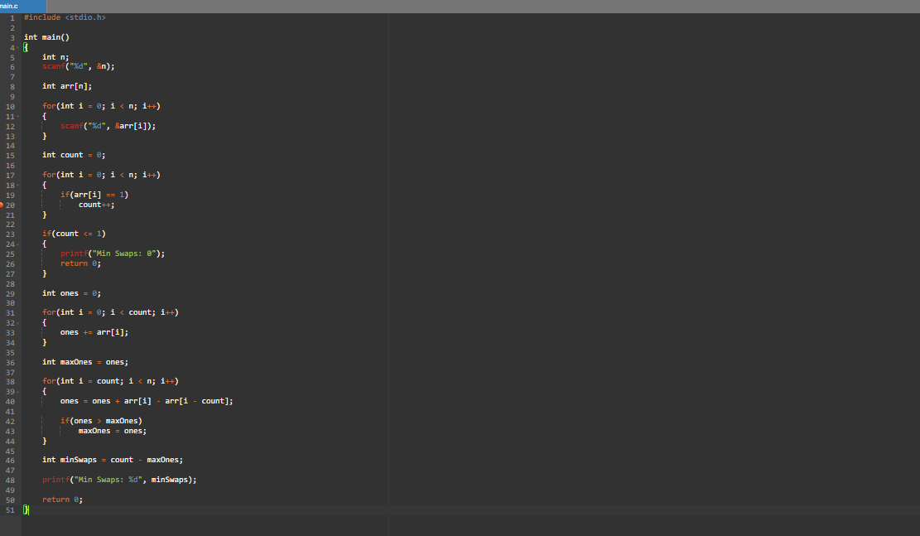
OUTPUT:
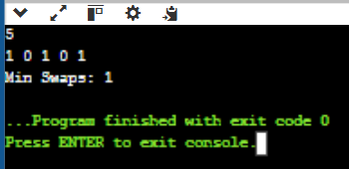
RESULT:https://github.com/prabha4678-git/24CSI024-25BAD049/blob/603b445bffb498311ccab7d2944e4b8a7e3888f2/excode3.c

QUESTION 4
AIM:
To write a C program to find the maximum number of consecutive tasks whose total energy cost does not exceed the given limit using the Variable-Size Sliding Window technique.

PSEUDO CODE:
START
Read N and P
Read array arr[N]
start ← 0
current_sum ← 0
maxLength ← 0
FOR end ← 0 TO N-1 DO
current_sum ← current_sum + arr[end]
WHILE current_sum > P DO
current_sum ← current_sum - arr[start]
start ← start + 1
END WHILE
IF (end - start + 1) > maxLength THEN
maxLength ← end - start + 1
END IF
END FOR
Print "Max Length:", maxLength
STOP

SOURCE CODE:
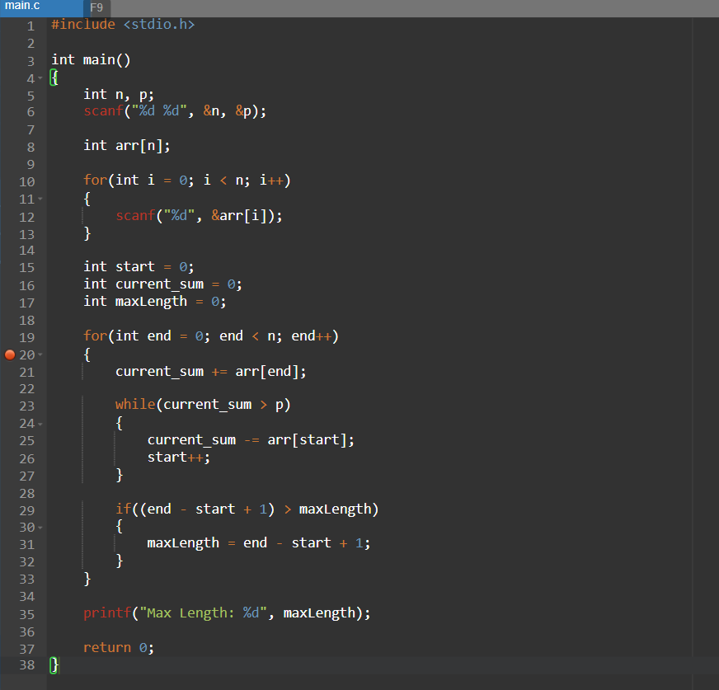

OUTPUT:
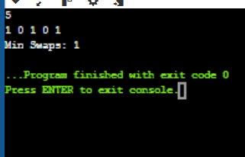

RESULT:https://github.com/prabha4678-git/24CSI024-25BAD049/blob/603b445bffb498311ccab7d2944e4b8a7e3888f2/ex2code4.c

QUESTION 5
AIM:
To write a C program to find the maximum element in every sliding window of size K using a Monotonic Queue (Deque) technique.

PSEUDO CODE:
START
Read N and K
Read array arr[N]
Create deque[N]
front ← 0
rear ← -1
FOR i ← 0 TO N-1 DO
WHILE front ≤ rear AND deque[front] < i-K+1 DO
front ← front + 1
END WHILE
WHILE front ≤ rear AND arr[deque[rear]] ≤ arr[i] DO
rear ← rear - 1
END WHILE
rear ← rear + 1
deque[rear] ← i
IF i ≥ K-1 THEN
Print arr[deque[front]]
END IF
END FOR
STOP

SOURCE CODE:
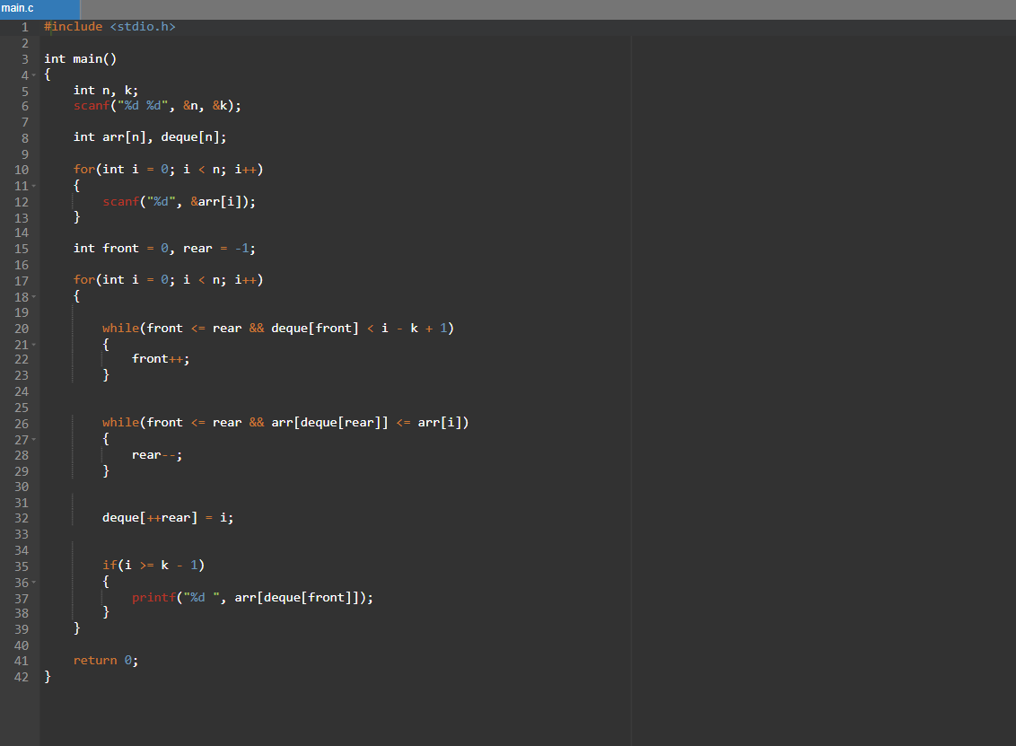

OUTPUT:



RESULT:https://github.com/prabha4678-git/24CSI024-25BAD049/blob/603b445bffb498311ccab7d2944e4b8a7e3888f2/ex2code5.c

